**DAILY ONLINE ACTIVITIES SUMMARY**

|  |  |  |  |  |  |  |  |  |
| --- | --- | --- | --- | --- | --- | --- | --- | --- |
| **Date:** | **09-06-2020** | | | | | **Name:** | **Nachiketh S Bhat** | |
| **Sem & Sec** | **6th  Sem ‘B’ Sec** | | | | | **USN:** | **4AL17CS119** | |
| **Online Test Summary** | | | | | | | | |
| **Subject** | | **CGV and CNSC improvement** | | | | | | |
| **Max. Marks** | | **CGV:30**  **CNSC:60** | | **Score** | | | **CVG:25**  **CNSC:41** | |
| **Certification Course Summary** | | | | | | | | |
| **Course** | E-Box [Start Course](https://courses.cognitiveclass.ai/courses/course-v1:developerWorks+BC0101EN+v1/jump_to/block-v1:developerWorks+BC0101EN+v1+type@course+block@course) | | | | | | | |
| **Certificate Provider** | | | **E-box** | | **Duration** | | | **Daily 1.30hr** |
| **Coding Challenges** | | | | | | | | |
| **Problem Statement:**  **1. C Program to rotate the matrix by K times.**  **2. Python to implement Perfect Sum Problem.**  **3. Java Program to print smallest and biggest possible palindrome word in a given string**  **4. Python Program to count even and odd numbers**  **5. Java Program to remove all white spaces from a string without using replace()** | | | | | | | | |
| **Status: done** | | | | | | | | |
| **Uploaded the report in Github** | | | | | **yes** | | | |
| **If yes Repository name** | | | | | <https://github.com/nachi0106/Daily-Activity/tree/master/Online-coding%20report/09-06-20> | | | |
| **Uploaded the report in slack** | | | | | **yes** | | | |

**Online Test Details:**

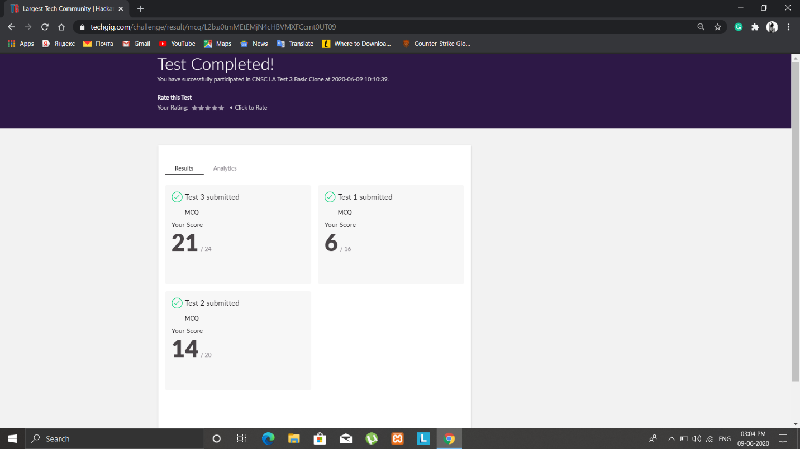

**Certification Course Details:**

**E-Box Classes:**

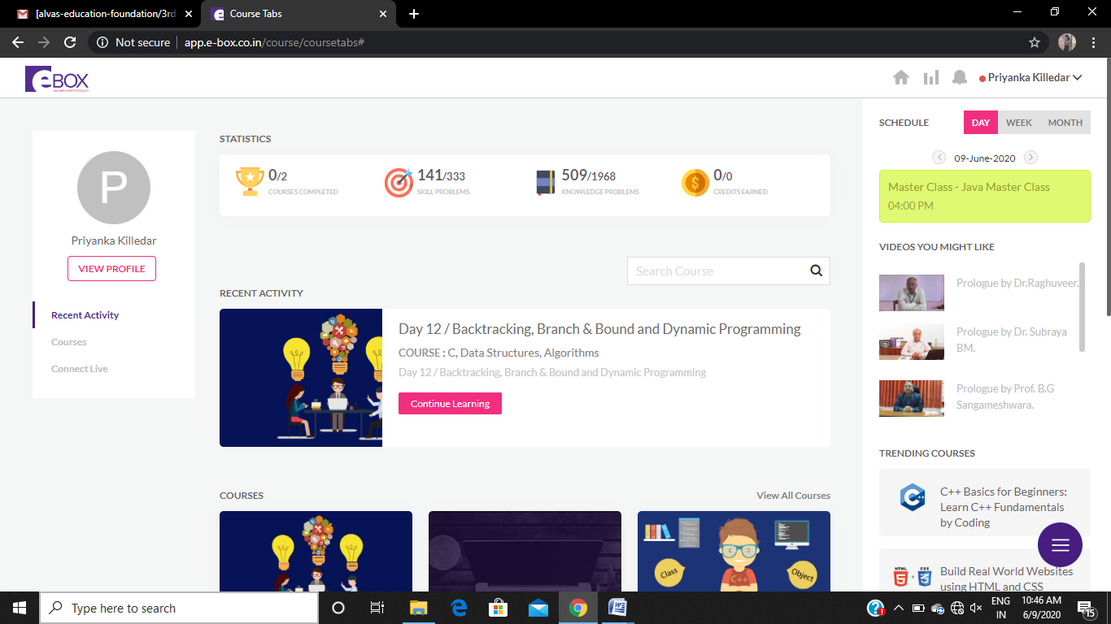

* **JAVA CLASS**

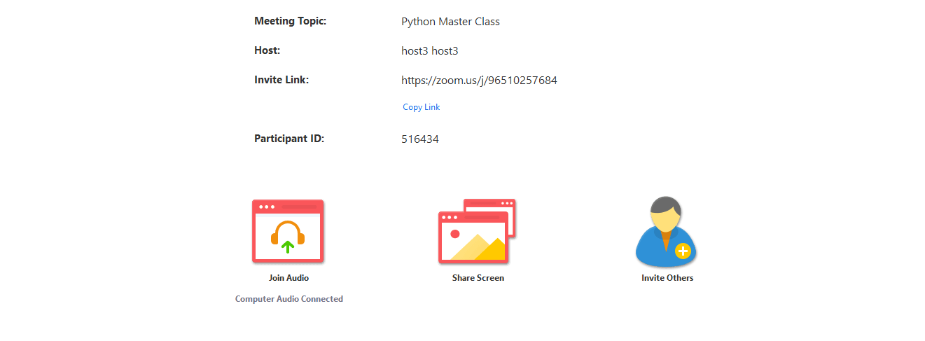

TIME: 4pm to 5.30pm

ONLINE PROGRAMING

P-1

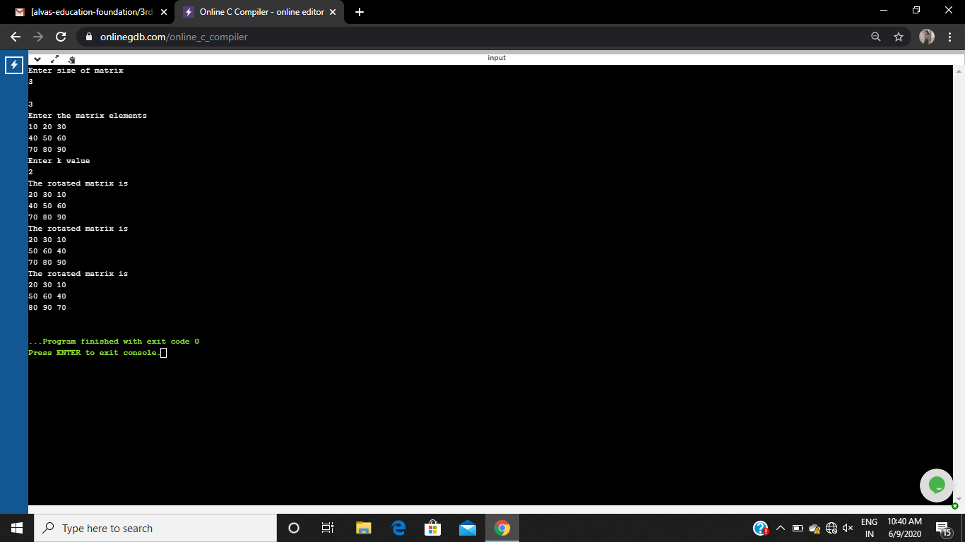

P-2

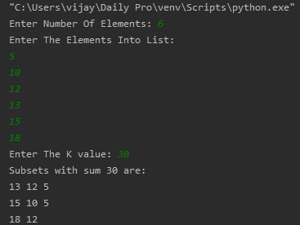

P-3

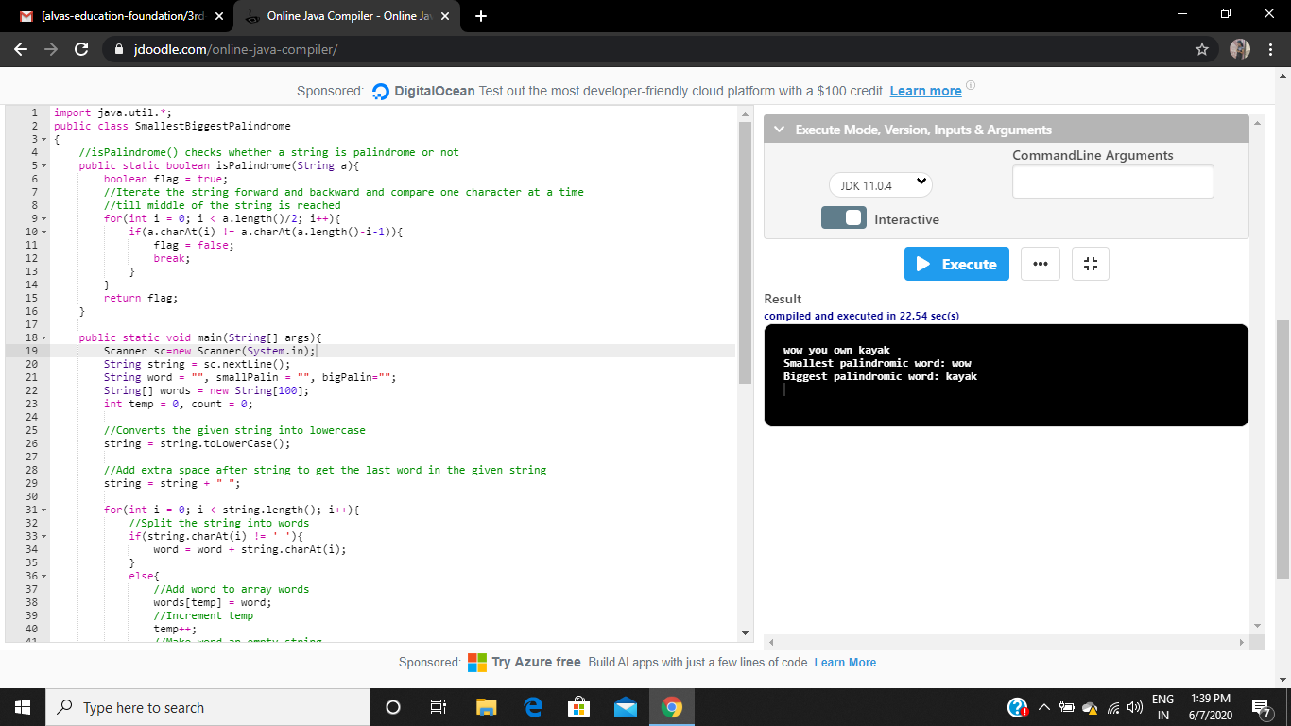

P-4

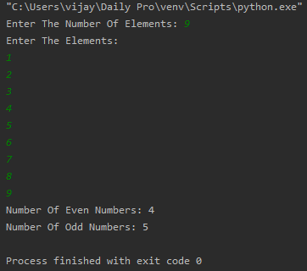

P-5

